DYMOCK & DISTRICT
LATE CHRYSANTHEMUM SHOW
In
DYMOCK PARISH HALL
(Near Newent, Gloucestershire, GL18 2AG)
SUNDAY 31st October 2021

Judging: 11:00am
Show Opens: 1:30pm
Staging of Exhibits: 8:00am – 10:30am
All entries to be presented to the show secretary before 10:30am
Secretary: Mr N.K. Thick
Telephone: 01531 890453
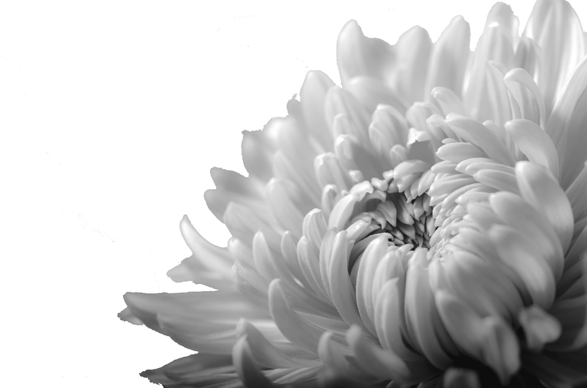
Email: jenniferthick@aol.com
Presentation of awards at approximately 4:00pm
Committee: J.A. Powell, K. Smith, N.K. Thick, Mrs. J.B. Thick

NO ENTRY FEE
Prize Money: 1st - £3
2nd - £2
3rd - £1

Judge: Mr. C. Parkes

Rules and Regulations
- All exhibits must have been grown by the exhibitor in his/her own premises, or on land in his/her occupation for at least 3 months before the show.
Any exhibitor infringing this rule will be disqualified.
- No exhibitor shall be awarded more than one prize in the same class.
- All exhibits must be staged for the judges by 10:30am, when the hall will be cleared and only those officially engaged in the show will be allowed inside. The hall will be open for the reception of exhibits from 8:00am. No exhibits shall be removed before the presentation of the awards without the consent of the committee.
- The decision of the judges shall be final, and they have the power to withhold any prizes if, in their opinion, there are not enough exhibits, the standard reached is not high enough or any rules have been broken.
- Exhibitors must show the exact number of specimens mentioned in the schedule or they will be disqualified.
- Any protest must be made in writing and lodged with the secretary by 4:00pm on the day of the show, accompanied by a fee of £1 which sum will be forfeited if the objection is considered frivolous. In the event of any dispute as to the qualification of any exhibitor to compete, the decision of the committee will be final.
- Every possible care will be taken of the exhibits, but the committee will not hold itself responsible for any loss or damage that may occur.

Cups and Medals
The Zoya Perpetual Trophy – winner of class 1
The L.C. Thick Perpetual Memorial Trophy – winner of class 2(Les was a founder member of the Society)
The Dymock Perpetual Trophy – best vase other than singles or N.C.S medal winner
The Beauchamp Arms Perpetual Salver – most points in classes 1-22
N.C.S. Silver Medal – best exhibit
N.C.S. Bronze Medal – second best exhibit
Classes
- 2 vases, 5 blooms per vase, 1 distinct cultivar per vase, 2 distinct cultivars from sections 3,4,5,6 & 7
Prize money 1st £15, 2nd £10 3rd £5
- 2 vases of singles, 5 blooms per vase, 2 distinct cultivars
Prize money 1st £7 2nd £5 3rd £3
- 3 vases of medium exhibition, 3 blooms
- 3 vases of large exhibition, 3 blooms
- 1 vase of large or medium exhibition, 1 bloom
- 1 vase, 5 blooms, 1 variety incurves
- 1 vase, 5 blooms reflex, 1 variety
- 1 vase, 5 blooms intermediate, 1 variety
- 1 vase, 5 blooms anemone, any varieties
- 1 vase, 5 blooms of singles, 1 variety
- 1 vase, 3 blooms incurves, 1 variety
- 1 vase, 3 blooms reflex, 1 variety
- 1 vase, 3 blooms intermediate, 1 variety
- 1 vase, 3 blooms large singles, 1 variety
- 1 vase, 3 blooms medium singles, 1 variety
- 1 vase, 3 blooms anemone, 1 variety
- 3 blooms, fantasies, any variety, 1 bloom to a vase
- 2 vases, 3 blooms, all sections any varieties
- 1 vase, 1 bloom, any late flowering variety
- 1 vase, 5 blooms, not less than 2 varieties
- 1 pot mum, pot must not exceed 10”
- 1 vase, 3 stems spray chrysanthemums

The committee reserves the right to move vases before or after judging for display reasons only

Dymock Parish Hall
Ledbury Road
Dymock
Gloucestershire
GL18 2AG

